**St. Nicholas’ Primary School,**

**Longwood,**

**Co.Meath.**

[**www.stnicholasprimaryschool.com**](http://www.stnicholasprimaryschool.com)

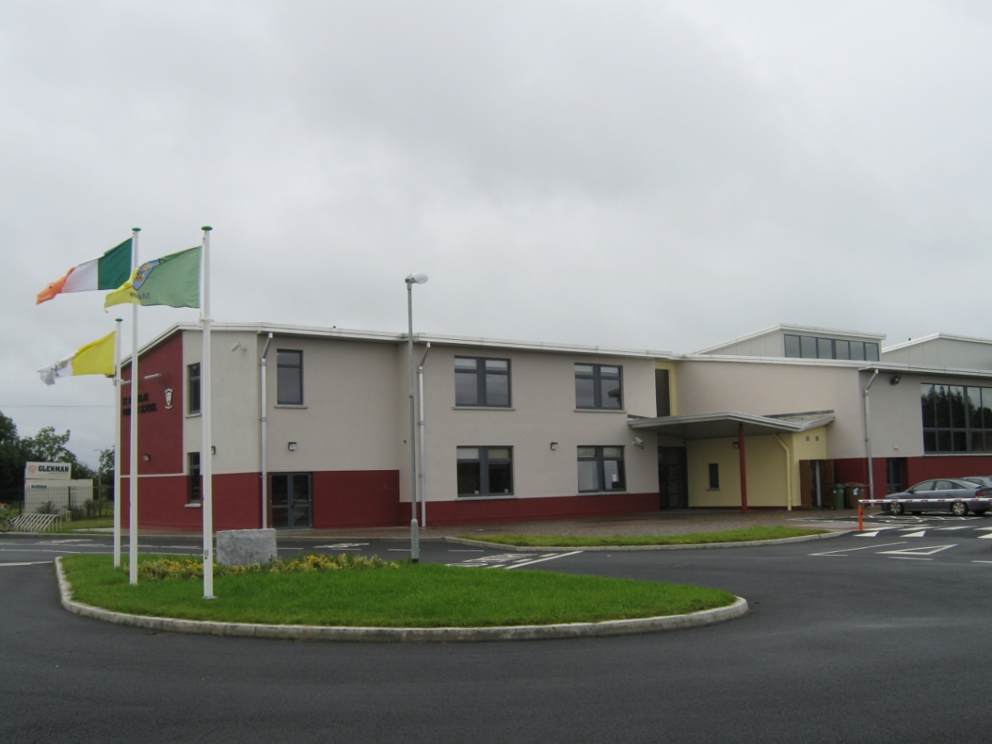

***Mission Statement***

St. Nicholas Primary School seeks to cherish and challenge our pupils in a safe, secure and attractive learning environment. We strive to provide quality learning experiences, that are engaging, enriching and enjoyable, through a broad, balanced and relevant curriculum.



**Welcome**

**Fáilte**

**Witaj**

**Bienvenue**

**Sveiki Atvyke**

**Prave**

**Bun Venit**

**Welkom**

**Laskavo Prosimo**

**Maligayang Pagdating**

**General Information**

School Address: Longwood, Enfield, Co. Meath.

Telephone number: 046-9555384

E-mail: info@stnicholasprimaryschool.com

Web: www.stnicholasprimaryschool.com

Fax: 046-9555687

Chairperson: Fr. Michael Kilmartin

Principal: Ms. Siobhán Henry.

Deputy Principal: Ms. Laura Barnewall

School Secretary: Mrs. Madeline Smyth

**The core values we cherish at our school are:**

*Care*

*Respect*

*Trust*

*Hope*

**Our School**

St. Nicholas’ Primary School, Longwood, Co. Meath is a Roman Catholic School, which operates under the patronage of the Bishop of Meath. We display the symbols of our rich Catholic faith tradition throughout the school and spend time as a school community in reflection, prayer, ritual, celebrating the Eucharist and other sacraments to develop the spiritual life of each person in the school community.

While St. Nicholas Primary School is a school with a Catholic ethos, it also gives due recognition to children of all other religious beliefs and none.

We are a developing 21 teacher school consisting of a Principal, 15 mainstream class teachers, a team of 5 Special Educational Needs Teachers and 4.5 SNAs.

**Child Protection**

The Board of Management recognises that child protection and welfare considerations permeate all aspects of school life and must be reflected in all of the school’s policies, practices and activities. Accordingly, in accordance with the requirements of the Department of Education and Skills, Child Protection Procedures for Primary and Post Primary Schools, the Board of Management of St. Nicholas’ Primary School, Longwood, has agreed the following child protection policy:

The Board of Management has adopted and will implement fully and without modification the Department’s Child Protection Procedures for Primary and Post Primary Schools as part of this overall child protection policy.

**The Designated Liaison Person (DLP) is Siobhán Henry.**

**The Deputy Designated Liaison Person (Deputy DLP) is Laura Barnewall.**

The Designated Liaison Person is responsible for ensuring that the standard reporting procedure is followed, so that concerns or suspicions of child neglect, emotional deprivation, physical abuse or sexual abuse, are referred promptly to the [Child and Family Agency Duty Social Worker.](http://www.tusla.ie/services/child-protection-welfare/contact-a-social-worker) In the event of an emergency where it is thought that a child is in immediate danger and the Children and Family Agency Duty Social Worker cannot be contacted, [An Garda Síochána](http://www.garda.ie/Stations/Default.aspx) will be contacted.

Our school’s ‘Child Protection Policy’ can be viewed in full on [www.stnicholasprimaryschool.com](http://www.stnicholasprimaryschool.com) and a copy of the policy is also on display in the main reception area of our school.

**Our School Curriculum**

***Language***

Irish/Gaeilge, English.

Maths

**Social Environmental and Scientific Education (S.E.S.E.)**

History Geography Science

**Arts Education**

Visual Arts Music Drama

Social, personal and health education (S.P.H.E.)

Physical Education (P.E.)

**Home School Links**

There are many examples in practice, of effective communication existing between the teachers and parents of our school. This co-operation and support is an essential ingredient in your child’s education.

1. Updated information, including newsletters from the Principal, are available on our school website.
2. A note in the child’s homework journal.
3. A letter to the parent or teacher.
4. Parent/Teacher Meetings: Parent/Teacher meetings are held every year in November.
5. School text messaging service ‘text a Parent’
6. If a child is experiencing a particular problem it is essential that parents communicate this to the teacher. Letting the teachers know will allow them to help the child to cope. Parents are asked to make an appointment with the teacher.

**The Board of Management**

It is the duty of the Board of Management to manage the school on behalf of the patron, and for the benefit of the students and their parents, and to provide or cause to be provided an appropriate education for each student at the school for which the Board has responsibility.

The Board of Management comprises the following members:

Chairperson: Fr. Michael Kilmartin

Principal: Ms. Siobhán Henry

Teacher Representative: Ms. Stacey Coburn

Patron’s Nominee: Mrs. Mary Flynn  
Community Representatives: Mrs. Rosemary Doyle and Mr. Martin Ennis  
Parent Representatives: Ms. Joyce Dixon and Mr. Declan Mooney

**Parents’ Association**

Our school is very fortunate to have a very active Parents’ Association, which is also affiliated to the National Parents’ Association.

The Parents’ Association is the structure through which parents/guardians in a school can work together for the best possible education for their children. The Parents’ Association works with the Principal, Board of Management and staff to build an effective partnership between the home and school. Partnership between the home and school is important, as with positive and active partnership children receive the best that primary education can offer.

You will receive regular updates from the committee regarding the work of the Parents’ Association and you are also invited to participate in all of its activities. You will also be invited to attend the Annual General Meeting and I would strongly encourage you to attend and consider becoming a member of the committee if nominated.

Chairperson: Ms. Sarahanne Douglas  
Secretary: Ms. Ciara Lorenzo  
Treasurer: Ms. Sinead Murray

**School Day**

School Opens - 9.00

Morning Break – 10.45 - 10.55

Lunch Break - 12.30 - 1.00

Infants Finish – 1.40

School Closes – 2.40

**School Dress Code**

The standard uniform for St. Nicholas’ Primary School consists of:

* Maroon v-neck jumper
* Grey trousers or skirt
* Light blue shirt
* School tie (available from school Secretary)

School tracksuits for P.E., are available for purchase from Ted Murtagh’s Menswear in Trim, we encourage children to wear them for P.E. Runners are also necessary for P.E. and the class teacher will choose the day for P.E. and let you know.

It would be helpful if children could label their coats, uniforms and other personal belongings.

**Attendance**

Pupils are required to be regular and punctual in their attendance at school. School commences at 9.00 a.m. Parents are asked to ensure that children are on time. A requirement exists under the Education Welfare Act that schools are obliged on four occasions throughout the school year, to report absences in excess of 20 days to the National Education Welfare Board. The Board of Management realises that there are many genuine reasons for children’s absence from school. Nonetheless, once your child has absences in excess of 20 days, you will receive notification from the school that the absence had been forwarded to the National Education Welfare Board (NEWB).

Please see newb.ie for further information.

**Absences**

All school absences must be accounted for. Parents are asked to submit a written explanation for all absences. If a pupil wishes to leave school early, the school should be notified at the earliest convenience. A ‘sign in/sign out’ booklet must be signed by the adult who is collecting the child.

**Home Time Collection Procedure for Jun./Sen. Infants 1.40 p.m.**

In order to ensure that your child is collected safely at the end of the school day, as the children emerge from the school building, the class teacher will arrange for all the children in the class to stand at the external wall of the school building. Parents are requested to stand well back while this routine is taking place. On the teacher’s signal, parents may then go to their child and take him/her by the hand. The children are reminded at this time, not to run towards the person collecting, but to wait until they are taken by the hand.

While this collection is taking place, the class teacher is observing in close proximity and can easily identify those children who are left standing at the wall and have not been collected. Those children are then supervised by the teacher until such time as the adult who is responsible for collection arrives. Your co-operation with this end of school collection routine is greatly appreciated and gives reassurance to any parent who may be delayed.

**Birthday Invitations/Birthday Cakes**

It is our school’s policy that birthday invitations are not given out by the children while in school. In the past it was noted by teachers that some children were disappointed at not being included in the invitation list and were preoccupied, to the point that concentration and learning were being affected.

Parents are also requested not to send in a birthday cake for sharing among all the pupils in the class. I hope that you appreciate that the sharing of cakes is time consuming, and results in time having to be spent cleaning up afterwards. The above request also ensures that children are not placing expectations on their parents to send in a cake on the occasion of their own birthday.

It would, however, be expected that the child would include some of the birthday cake from home, the following day in his/her lunchbox.

**Administration of Medicines**

The Board of Management requests parents to ensure that teachers be made aware in writing of any medical condition that a child may have (See Enrolment Form). Some children may need to have medication administered for an on-going medical condition e.g. asthma, diabetes. In all such cases, the parents/guardians of the child should contact the School Principal/Board of Management to see if suitable agreed arrangements can be put in place to facilitate the administration of such medication. No teacher may administer medicines to any pupil except on the instructions of the Board of Management. Parents/Guardians must sign a consent form for the child to administer the medication independently of adult involvement.

**Accidents**

Teachers supervise in the playground during break-time. Following a fall or a collision, minor cuts and grazes are treated in the school. The cut is cleaned with tissue and water, and a plaster/band aid may be applied. When children are enrolled in the school, parents sign a form giving permission to the school to administer the above care. In the event of a teacher being aware of a head injury or possible internal injury, parents will be contacted.

Should a medical emergency arise, and the school cannot make contact with the parents, a consent form granting permission to the school to bring the child to a doctor or A&E, and signed by parents at time of enrolment, is retained in the school.

**Head Lice**

If at any stage of the school year, your child requires treatment for head lice, please inform the school as soon as possible.

All parents of the pupils in the class will then be notified and advised re. detection and treatment options.

**All reports of head lice made to the school will be treated confidentially.**

**Information/Communication, Money etc.**

All information/communication or anything of a sensitive or confidential nature between school and home should be sent in a sealed envelope showing pupil’s name, teacher’s name and a brief reference to the enclosed material.

**Code of Behaviour**

A copy of the school Code of Behaviour/School Rules is given to all parents/guardians of new pupils. It can also be viewed on the school website during the month of September. A hard copy is also available from the school, on request. A consent form acknowledging your acceptance and co-operation with the Code of Behaviour, is retained in the school.

**Health and Safety**

Please note that the following are not permitted within the grounds of the school.

* Cycling
* Smoking
* Dogs

Finally.....

Your child’s welfare and education are our primary concerns. If there is anything we should know about your child, of which we may be unaware, please come and talk to us.

**“Education is not the filling of a pail, but the lighting of a fire.”**

**(W.B. Yeats)**

Siobhán Henry.

Principal.