Accelerated Reader

St Nicholas Primary School's Guide to Accelerated Reader
"At its heart, Accelerated Reader is simple. A student reads a book, takes an online quiz, and gets immediate feedback. Students respond to regular feedback and are motivated to make progress with their reading skills" - Renaissance
Contents
- What is Accelerated Reader?
- What is a STAR Reading Test?
- What is a Zone of Proximal Development (ZPD)
- What are Accelerated Reader quizzes?
- How can you get involved?
- Why are we using Accelerated Reader?
- Frequently Asked Questions
- Useful Links
What is Accelerated Reader?
Accelerated Reader is a computer programme that helps teachers manage, monitor and improve children's independent reading practice.
Your child chooses a book (with support) based on their interests and at his/her own level (this is a very important part of the programme) and reads at his/her own pace. When finished, your child takes a short quiz online - passing the quiz is an indication that your child has understood what has been read. Accelerated Reader gives both children and teachers feedback based on the quiz results, which the teacher then uses to help the child set targets and direct ongoing reading practice.
We have introduced this from year 3 upwards.
What is a STAR Reading Test?
A computer-adaptive reading test used to assess pupils' reading ability to determine recommended reading levels for Accelerated Reader.
This is a multiple choice reading assessment, completed on the computer, lasting approximately 20 minutes. Questions continually adjust to your child's response, so if their answer is correct, the difficulty will increase. If they miss a question or give an incorrect answer, the difficulty level is reduced.
The STAR reading test, along with teacher judgement, assists us in identifying a child's ZPD (Zone of Proximal Development) range. (Don't worry - more about 'ZPD' in the next section!)
Children who are taking part in the programme will usually complete a STAR reading test at least 3 times a year.
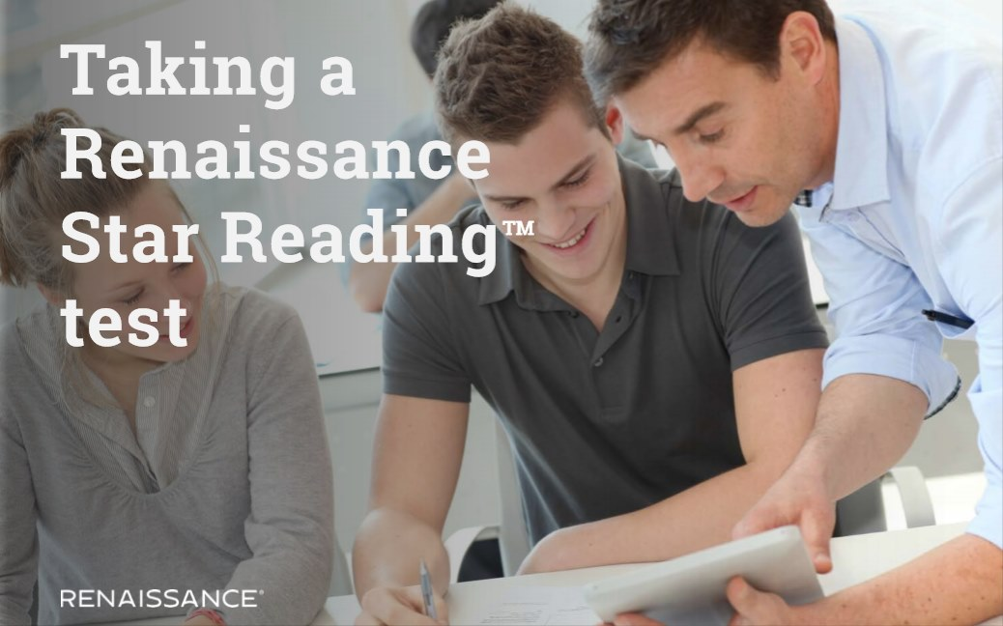
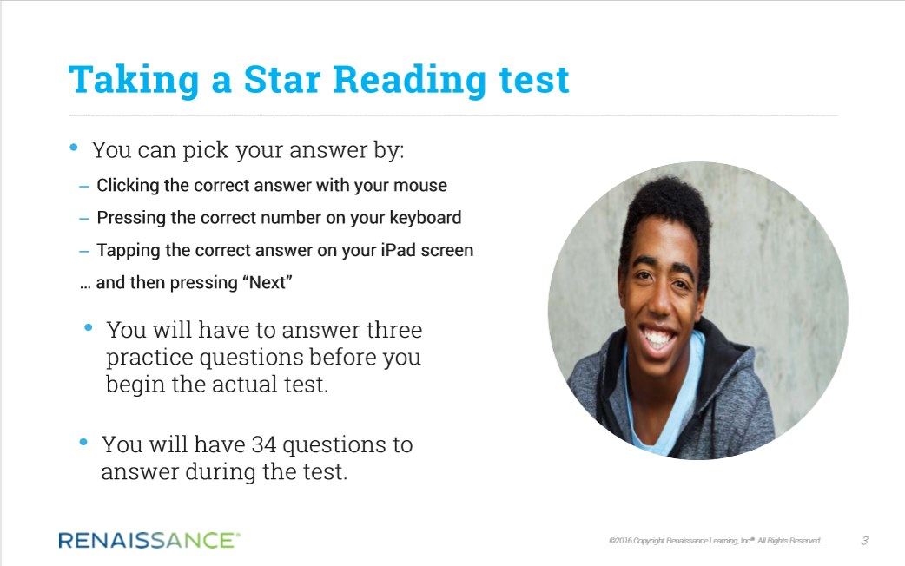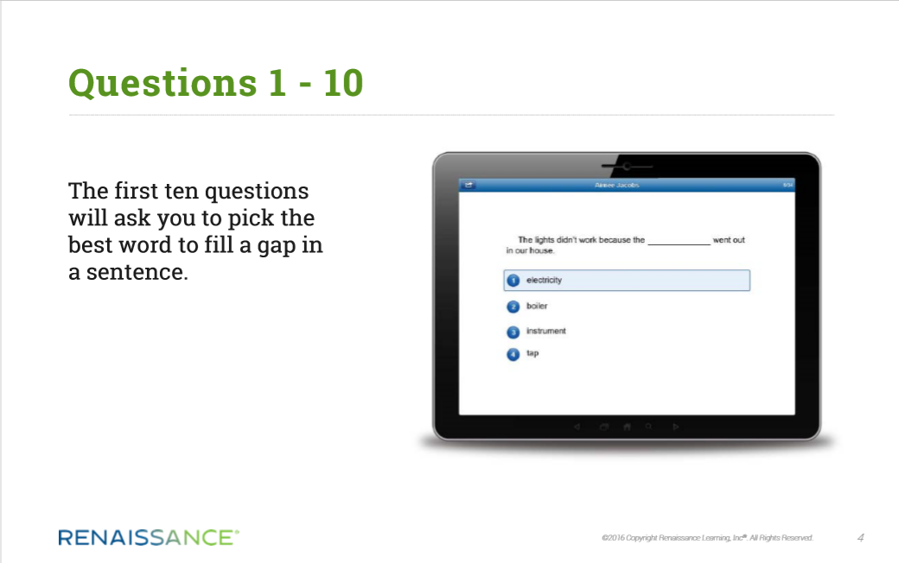
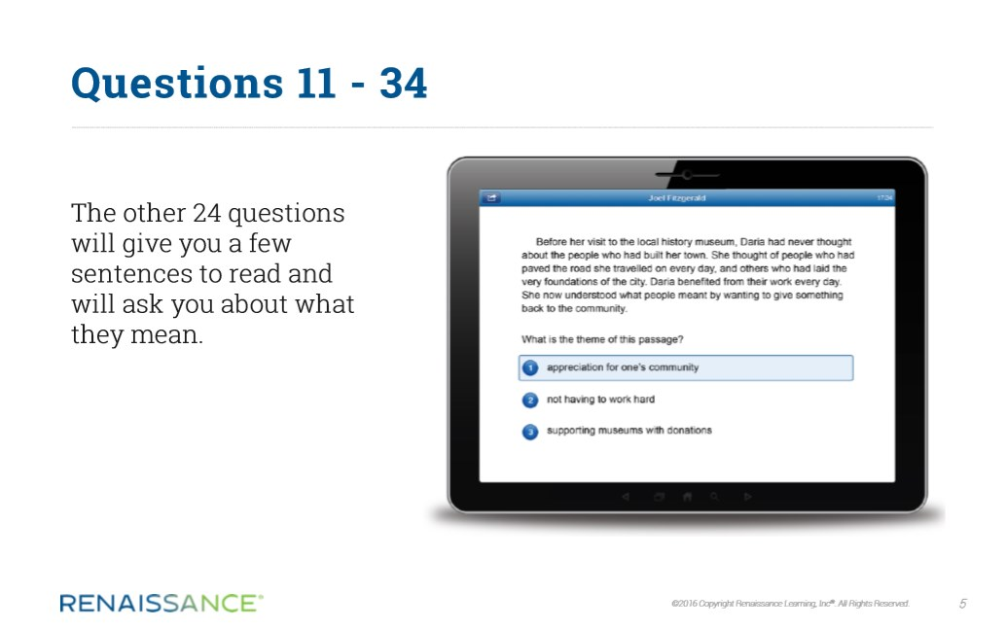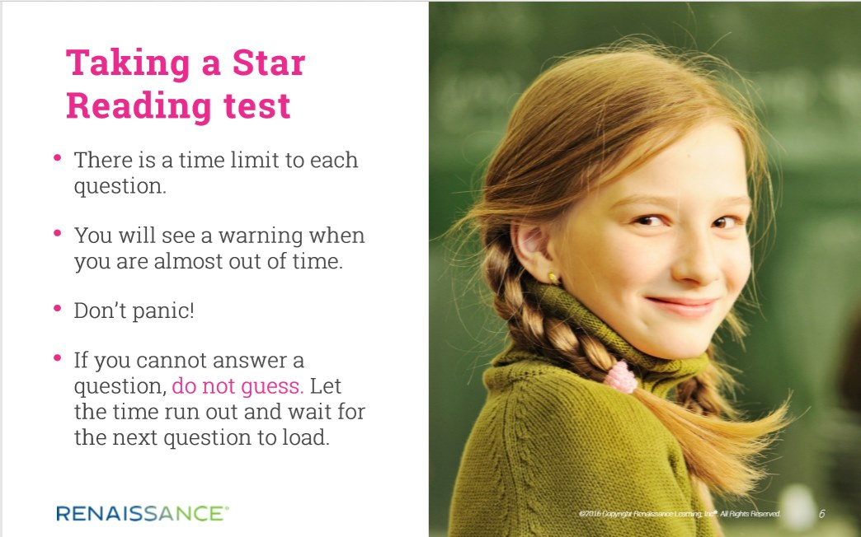

What is a Zone of Proximal Development (ZPD)?
After your child takes a STAR reading test the teacher will assess the results and give them a ZPD range. The range aims to challenge a child without causing frustration or a loss of motivation. In other words the book should be 'not too easy' or 'not too hard'!
For example a ZPD could be 2.4 - 3.6, this shows the range of texts your child should aim to read with books nearer 3.6 being more difficult. Books not within the range may be too easy/too challenging at this time.
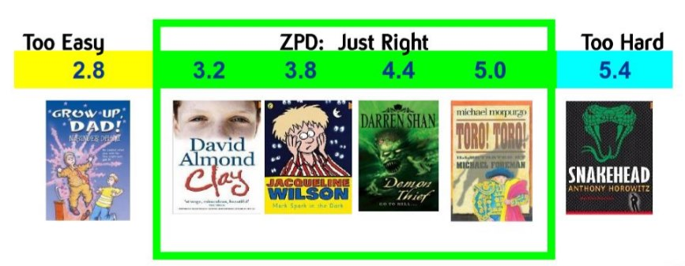
We have invested a lot of time and effort into labelling and organising our school library to make it easier for children to find a book at their own level. Our school librarians will assist pupils to find a suitable book at their ZPD level.
The AR Reading books (fiction and non-fiction) are colour coded according to their book level. To ensure children experience success from the outset they should begin by taking books at the lower end of their ZPD range. Your child will know their ZPD range/colour and the books they should be choosing. This will also be indicated in their learning diary as a reminder. A ZPD can change through the year based on STAR reading tests, professional judgement and quiz results.
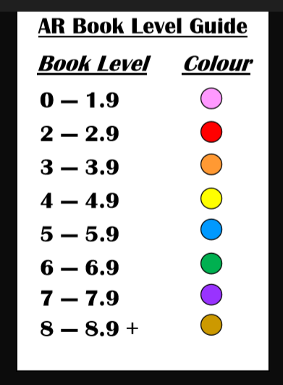
1 - Book Level Colour Guide
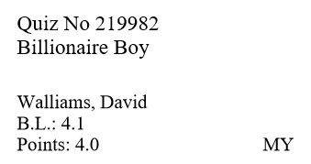
2 - AR Book Label
Information about the Accelerated Reader books (from the school library) can be found on a label on the back of the cover.
This label tells you the:
- Quiz Number
- Title and author
- Book level
- Points the child will earn if they complete the quiz
- Interest level of the book e.g. LY - Lower Years (5-8 years), MY - Middle Years (9-13 years) and UY - Upper Years (14+ years)
What are Accelerated Reader Quizzes?
When your child has finished reading a book they will be given time to take a quiz independently online in school only. It is best if a quiz can be taken within 48 hours of finishing a book, but this will depend on class timetables and availability of computers/ipads. Depending on the book level of the quiz this may be 5, 10 or 20 questions long and will take around 5 minutes to complete. The quiz assesses general comprehension of the book and results are calculated and shown to the child instantly.
Your child can take a quiz when:
- they have read a book independently
- a teacher has read a book to them e.g.. class novel
- they have read a book with someone e.g. parent/carer/sibling/friend
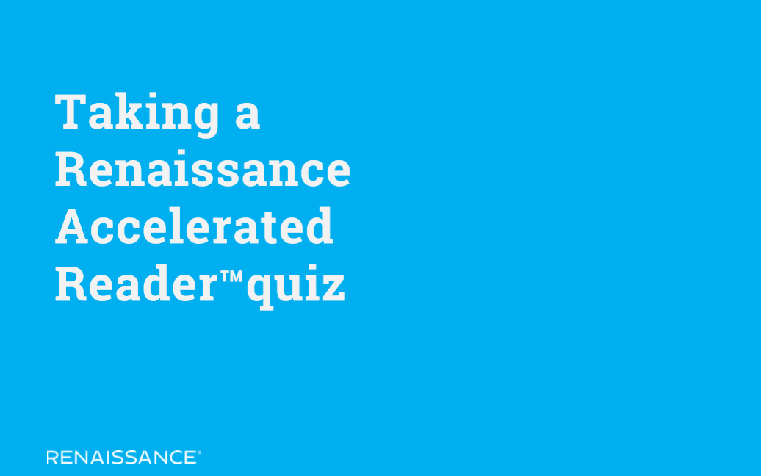

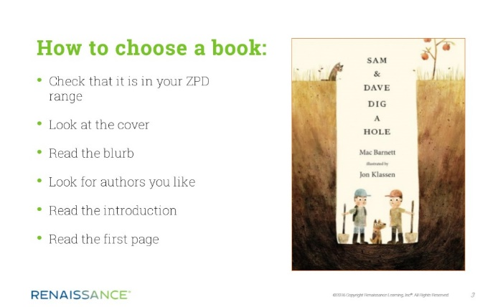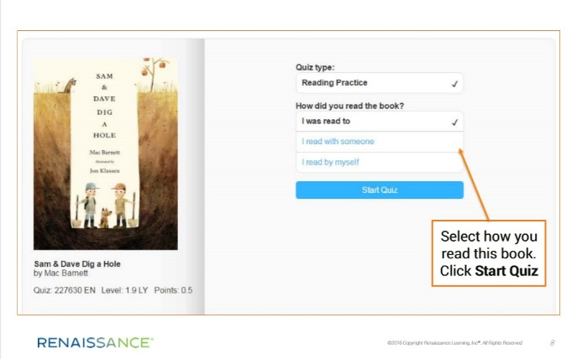
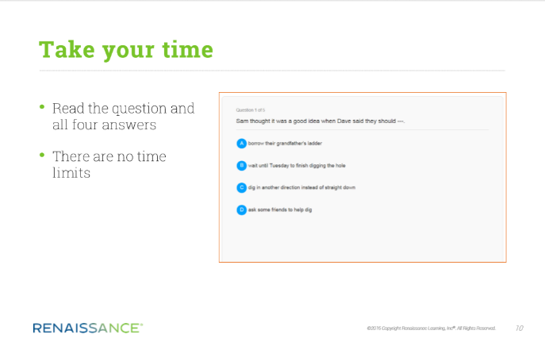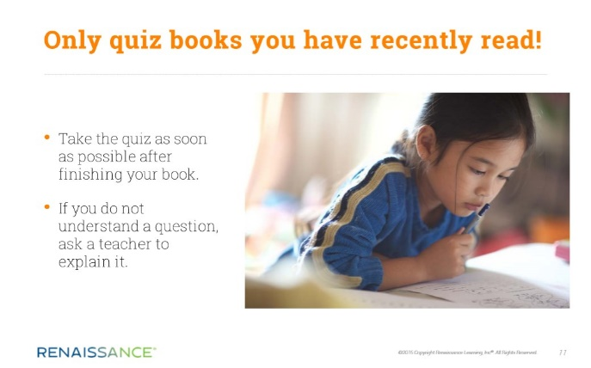
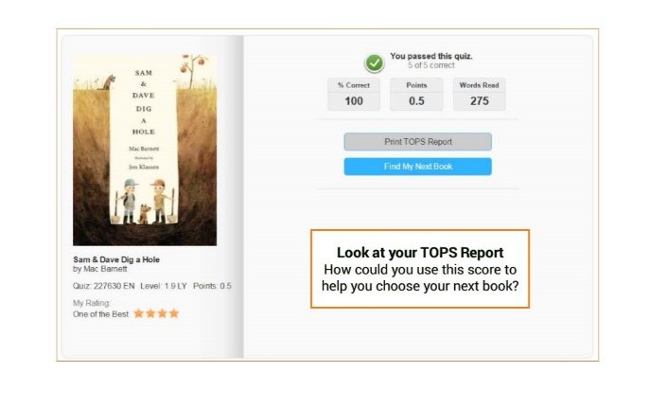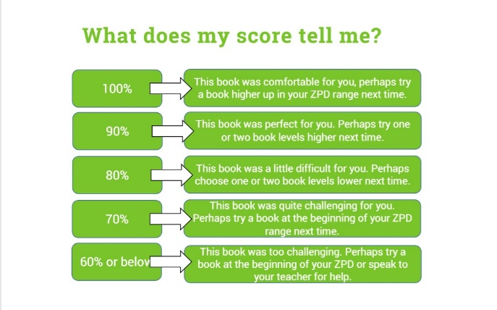
Your child can bring in books from home or the local library as part of Accelerated Reader if their teacher feels they are suitable. Book levels can be checked at home by using the website www.arbookfind.co.uk
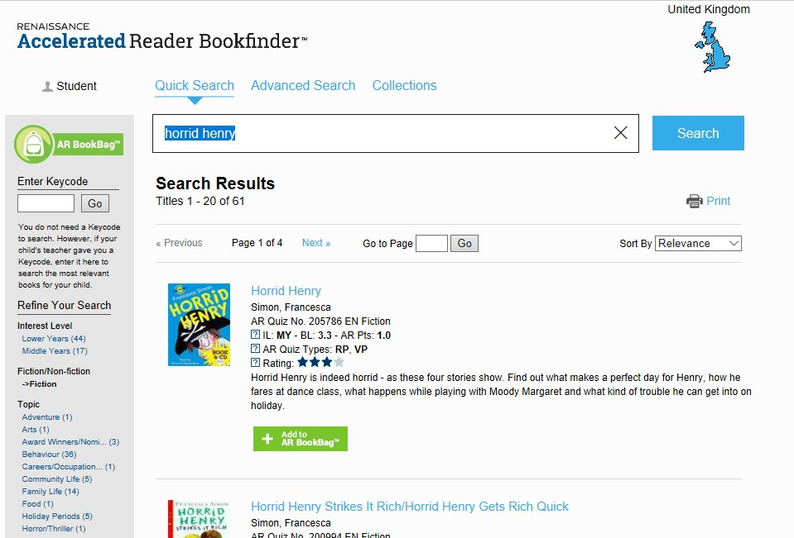
How can you get involved?
As with anything, performance improves practice, which in turn will hopefully improve reading attainment. We provide lots of opportunities for reading in school but you can help by providing a culture of reading at home.
- Encourage your child to read at home every day because they will get better at reading if they practice. Find out what your child's ZPD is and help them to read books at their own level
- Ask what books they are reading and how they are getting on with any quizzes completed
- Create a culture of reading in your household by reading with your child, have some books available at home, visit your local library and by letting your child see you reading too
- When reading with your child, stop and ask them questions about the text to be sure your child is understanding what they have read
- Try to regularly discuss books that everyone in your family is reading or has read
Reading with your child, no matter what age, is an important part of developing good reading skills and a lifelong love of reading.
Why are we using Accelerated Reader?
- Accelerated Reader is proven to help children become better readers
- Accelerated Reader encourages children to read more and rewards them for their effort and achievement
- When children read books at their appropriate level they experience success and grow in confidence and reading stamina
- The teachers work with children to set appropriate targets based on each child's reading ability
- Children can choose their own books to read. This makes reading a much more enjoyable experience as they can choose books that are interesting to them.
Frequently Asked Questions
1. Who is taking part in Accelerated Reader?
At the moment, everyone from 1st class to 6th class Class uses Accelerated Reader. The teacher will decide when it is appropriate for the pupils to take their first STAR Reader test.
2. How do I know what my child's ZPD is?
Once your child has taken part in a STAR, their ZPD will be written in their reading log with their range on it. This will be updated when necessary.
3. How is a book level chosen?
The book levels are calculated by Accelerated Reader and are based on varying sentence length and vocabulary difficulty.
4. How do I find books at my child's level?
Their school library book will have a coloured sticker on the spine or the top left of the book and should have an AR sticker stuck inside of the front cover of the book. You can also use the website www.arbookfind.com to find out the level of any book. If the book does not appear on the website then it is not an AR book...yet!
5. There are two colours on my child's book, which one is it?
It is the small coloured label on the spine with the ZPD number on. The ZPD is also on the label on the back of the book.
6. Can my child take a quiz at home?
No, quizzing will only take part in school. We encourage you to read with your child and discuss what they read with them at home instead.
7. Will taking quizzes not take the fun out of reading?
In most cases, children enjoy taking the quizzes. Since they are reading books of their own choice, at their own reading and interest levels, they are more likely to be successful. This is satisfying for most children. Best of all they learn and grow at their own pace.
8. Why is my child's ZPD so wide or narrow?
This depends of skills your child has mastered and the skills they need to develop. The ZPD will broaden as your child becomes secure with a skill, for example decoding, word recognition, inferring what will happen next or retrieving information of the text.
Useful Links
UK website www.renlearn.co.uk/accelerated-reader/
Parent's Questions and Answers https://resources.renlearnrp.com/UK/AcceleratedReader/RPRTParentsGuideToARUK.pdf
Parent's Guide PDF www.renlearn.co.uk/wp-content/uploads/2014/08/Parents-Guide-to-Accelerated-Reader_2016-17.pdf

